

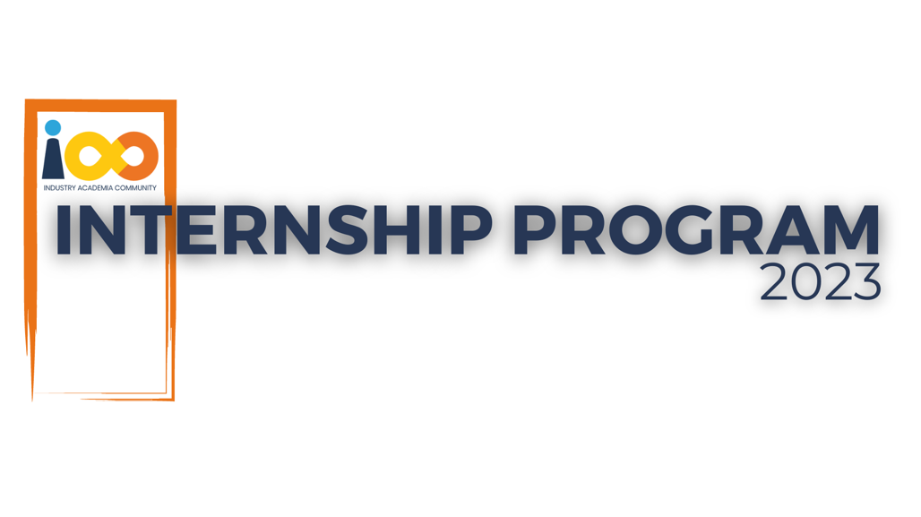

PROJECT REPORT

FULL STACK DEVELOPMENT  
  
PCONNECT (Professional connection website)

|  |  |  |  |
| --- | --- | --- | --- |
| **Created By:** | SINGH PRINCE LAXMI | **Approved By:** | Mr. V Manikanth Babu |
| **Created On:** | 23-09-2023 | **Approved On:** | DD-MMM-YYYY |

Page left blank intentionally

**INDEX**

**1** **PROJECT DETAILS** 2

**2** **SUMMARY** 2

**3** **INTRODUCTION** 2

3.1 Background 2

3.2 Stakeholders 2

3.3 Objectives 2

**4** **METHODOLOGY** 2

4.1 Considerations & Assumption 3

4.2 Approach 3

4.3 Activities 3

**5** **TARGETTED V/S ACHIEVED OUTPUT** 3

**6** **CONCLUSION** 3

**7** **APPENDICES** 4

7.1 Appendix A – Title 4

**General Instructions for using the Live Project Report Template**

* This template and the subsequent document created using this template is a confidential document and is the intellectual property of Cloud Counselage Pvt. Ltd. Circulating it outside of the organisation without the consent of Cloud Counselage Pvt. Ltd. is the breach of company policies and will lead to legal actions
* This template is a guideline document to communicate the implementation of design ideas and the results of the work to the stakeholders.
* The **text between inequality (< >) is to be replaced** by relevant text
* Please **remove the yellow highlight on the Text** between the inequality (< >). This is done to help you notice the text to be changed/replaced
* The text in *italics* highlighted in grey is just for reference and should be removed after adding the relevant text

# **PROJECT DETAILS**

|  |  |  |  |
| --- | --- | --- | --- |
| **Project Name** | PConnect (Professional Connect Website) | | |
| **Project Sponsor** | None | | |
| **Project Manager** | Ms. Harshada Topale | | |
| **Start Date** | 05-08-2023 | **Completion Date** | 21-08-2023 |

# **SUMMARY**

The Professional Connect Website is a platform designed to assist undergraduate students in expanding their industry reach and understanding. Its core objectives include facilitating networking opportunities with industry professionals, providing exposure to real-world industries, and offering learning experiences. Through user and professional profiles, algorithm-based matching and students can connect with experts in their fields of interest. The platform also offers a wealth of industry related resources and information, including articles, videos and event listings.

In essence, the professional connect website acts as a bridge between students and the professional world, helping them establish meaningful connections, gain practical insights, and develop their careers. It embodies the importance of networking and industry exposure for aspiring professionals.

# **INTRODUCTION**

## Background

In the currently scenario of uncertainty the only thing that can help in professional growth is knowledge about the industry, skills developed by continuous learning and a network of strong professional who can support us in our career growth by guiding us and sharing various opportunities. Therefore it would be helpful to have a website that is used to find the right job or internship, connect and strengthen professional relationships, and learn the skills you need to succeed in your career.

The website aims to address the pressing need for a comprehensive resource that empowers students to connect with industry experts, explore various career opportunities, and gain practical insights. By serving as a virtual bridge, it offers a unique solution to the multifaceted challenges faced by undergraduate students in their quest for professional success.

## Stakeholders

The stakeholders in the Professional Connect Website project are critical to its success:

**Undergraduate Students:** The primary beneficiaries of the platform, students, seek opportunities for growth, networking, and career development. They are the end-users who will interact with the website to connect with professionals and access educational resources.

**Industry Professionals:** Industry experts and professionals play a pivotal role as stakeholders. They have the knowledge and experience that students aspire to tap into. By participating on the platform, they contribute to the development of future professionals while expanding their own networks.

**Project Team:** The dedicated team responsible for the design, development, and maintenance of the website is a key stakeholder. Their expertise and commitment are crucial to delivering a functional and user-friendly platform.

## Objectives

The objectives of the Professional Connect Website project are multi-faceted, encompassing several key goals:

**Facilitating Networking:** The primary objective is to provide a platform where students can easily connect with industry professionals. Networking is essential for career growth, and the website aims to make it accessible to all users.

**Industry Exposure:** The platform seeks to offer students a glimpse into real-world industries. By providing insights and access to professionals, it equips students with a deeper understanding of various sectors.

**Learning Opportunities:** Educational resources, including articles, videos, and event listings, are made available to users. These resources serve as valuable tools for students to develop the skills needed to succeed in their careers.

**User-Friendly Interface:** The website aims to provide an intuitive and user-friendly interface to ensure that students, regardless of their technical expertise, can easily navigate and benefit from its features.

# **METHODOLOGY**

These conventions are all about the positions of line breaks, how many characters should go on a line, and everything in between.

## Considerations & Assumption

**Resource Constraints:** The project team acknowledged resource constraints as a primary consideration. This encompassed limitations in terms of time, budget, and available manpower. To address these constraints, a lean and efficient development approach was adopted. It was essential to optimize the allocation of available resources to ensure the successful completion of the project within the stipulated time frame.

**Technological Landscape:** Consideration of the existing technological landscape was crucial. The project assumed that the chosen technology stack and development tools were appropriate for the project's requirements. This assumption was made after a thorough assessment of available technologies, their scalability, and their compatibility with the project's objectives.

**User Needs:** An essential consideration was understanding the diverse needs of the target user group—undergraduate students. It was assumed that students sought a user-friendly platform that seamlessly integrated networking, industry exposure, and educational resources. This assumption guided the design and development process, with an emphasis on user-centric features and an intuitive interface.

**Security and Privacy:** Recognizing the sensitivity of user data, the project considered security and privacy as paramount concerns. It was assumed that stringent security measures and data privacy protocols would be necessary to protect user information. This assumption led to the implementation of robust data encryption, secure user authentication, and adherence to data protection regulations.

## Approach

A systematic approach was adopted to ensure project success:

**Requirement Gathering:** A detailed analysis of user needs and industry requirements was conducted.

**Design & Development:** Detailed design specifications were created before software development commenced.

**Testing:** Rigorous testing procedures were followed to guarantee a bug-free platform.

**User Training:** Comprehensive user training was provided to ensure effective platform utilization.

## Activities

Key project activities included:

Extensive requirement elicitation through user interviews and market research.

Creation of detailed design specifications to guide the development phase.

Software development, adhering to industry best practices and coding standards.

Rigorous testing, including unit testing, integration testing, and user acceptance testing.

User training sessions to familiarize users with the platform's features and functionality.

# **TARGETTED V/S ACHIEVED OUTPUT**

**Targeted Output:** The initial goal of the Professional Connect website was to create a platform exclusively tailored for undergraduate students. The primary objective was to assist these students in expanding their industry knowledge and professional network. Key features envisioned at the outset included user registration, profile creation, profile editing, and the ability to upload essential documents such as certificates and photos. The website aimed to facilitate meaningful connections with industry professionals, offer exposure to real-world industries, and provide valuable learning experiences.

**Achieved Output:** The Professional Connect website has successfully achieved its initial objectives. It boasts a robust user registration and login system, ensuring a secure and personalized experience for each student. The profile creation process has been streamlined, allowing users to enter their educational background, skills, and interests. Furthermore, students can upload profile photos and essential certificates, enhancing their professional profiles.

**Targeted Output:** One of the key features envisioned for the website was the ability to search for and connect with industry professionals. The targeted output included a user-friendly search functionality that allowed students to discover profiles based on criteria such as industry, job role, or location. It aimed to create a dynamic platform where users could send connection requests, exchange messages, and establish valuable professional relationships.

**Achieved Output:** The achieved output reflects the successful implementation of these networking features. Users can search for profiles using various filters, including industry, expertise, and location, making it easier to find relevant connections. The website supports connection requests, ensuring that students can reach out to professionals they find interesting. Messaging functionality has been seamlessly integrated, enabling users to engage in meaningful conversations with their connections.

**Targeted Output:** Another crucial aspect of the website's vision was to provide students with access to a wealth of industry-related resources and information. This included articles, videos, and event listings aimed at enhancing their industry knowledge. The website aspired to be a one-stop destination for students seeking to stay updated with the latest industry trends and developments.

**Achieved Output:** The website has exceeded expectations by delivering a comprehensive library of learning resources. Users can access articles, videos, and event listings, empowering them to stay informed about their chosen industries. The content is regularly updated to ensure relevance and usefulness. Additionally, the website has incorporated features for users to share their insights and experiences, fostering a collaborative learning environment.

**Targeted Output:** In conclusion, the Professional Connect website has successfully achieved its initial objectives of providing a platform for undergraduate students to grow their industry knowledge and network with professionals. It has become a valuable tool for students looking to kickstart their careers and gain practical insights.

**Achieved Output:** The achieved output aligns with our initial vision, and the website is poised for future growth. It has garnered a user base of enthusiastic students and professionals who actively engage with the platform. As we move forward, we plan to expand the website's features by introducing more interactive learning tools, mentorship programs, and industry-specific forums. The Professional Connect website is on its way to becoming an indispensable resource for the career development of undergraduate students.

# **CONCLUSION**

The Professional Connect Website stands as a milestone in empowering undergraduate students for success in their careers. By bridging the gap between academia and industry, it offers a holistic approach to professional development.

**Empowering Students:** This platform is designed to empower students, providing them with networking opportunities, industry exposure, and valuable learning resources. It equips them with essential tools for a successful career journey.

**Networking and Knowledge Sharing:** The platform fosters meaningful connections, enabling students to engage with industry experts and peers. It encourages knowledge sharing and collaborative learning, enriching students' understanding of real-world industries.

**Adaptability and Growth:** The commitment to continuous improvement ensures the platform's relevance in a dynamic job market. User feedback mechanisms and iterative development cycles will keep the platform adaptive and responsive to evolving needs.

**A Bright Future:** The launch of the Professional Connect Website opens doors to a brighter future for students, professionals, educational institutions, and employers. It creates an ecosystem where talent meets opportunity.

**Acknowledgments:** We acknowledge the dedicated project team and stakeholders whose contributions were essential to bringing this vision to life.

**Looking Ahead:** As students and professionals engage with the platform, their contributions will shape its growth and impact. The platform embodies innovation, collaboration, and empowerment, poised to make a lasting impact on the lives and careers of undergraduate students.

In conclusion, the Professional Connect Website is a transformative force in education and career development. It symbolizes the spirit of innovation and empowerment, with a bright future ahead. The journey continues, and success beckons for all who engage with this powerful platform.

# **APPENDICES**

## Appendix A – Title

<Add component table as required>